**Layout and Organization**

**General Description**

The function of this subsystem is to develop a layout that allows for modularity for future teams, as well as, establishing a wire organization system. The robot must be plug and play adaptable, so a slotted tray system was developed to move around components easily on the robot. Organization has also been an issue for competition teams. Therefore, being proactive by grouping wires, organizing them, and labeling them is important.

**Equipment, Parts, Software Used**

|  |  |
| --- | --- |
| Part Name (Quick Specs) | Link to the part purchased |
| Wire Labels | https://www.amazon.com/Management-Wmiwulien-Waterproof-Electronics-Handwriting/dp/B0B2N1J2SF/ref=asc_df_B09R29CL8P/?tag=hyprod-20&linkCode=df0&hvadid=652502670956&hvpos=&hvnetw=g&hvrand=4296422276430482524&hvpone=&hvptwo=&hvqmt=&hvdev=c&hvdvcmdl=&hvlocint=&hvlocphy=9013670&hvtargid=pla-2060990641110&mcid=2e52fe3b89243ac99c5968c8cf339fd6&th=1 |
| Stand-off Screws | https://www.amazon.com/Saiper-Spacers-Standoff-Assortment-Quadcopter/dp/B07SWWVW8G/ref=sr_1_3?crid=9FAJCYBVW1DY&dib=eyJ2IjoiMSJ9.PB_5nfHqjsdgCPllpzIsidMhTza6fcv53GJevXMi6Fc8ae_LDPo0avmKEQrqcJSYUDPim2C_fwbfgVbpUbUwH8s6DapHumxWJZMdK9V1HaCCoYIRveqc3Fu9xM4WjftYQc75QyaMSQBOBn6Fg2dc9XOpC8lLJ2rZlqhhAICR7shpPu0SrNKHr5T0w51fqhsFnIlbjySIgv3Vod3ckCtivvgODGp8JmSDnqA2VkcMUJA.OzJEn0wkm-mhMPbeZJhPuJ5UT_FHAnUwZTW-H2zFJBA&dib_tag=se&keywords=standoff+screws+for+arduino&qid=1711915251&sprefix=stand+off+screws+for+ardunio%2Caps%2C200&sr=8-3 |

**Schematic**

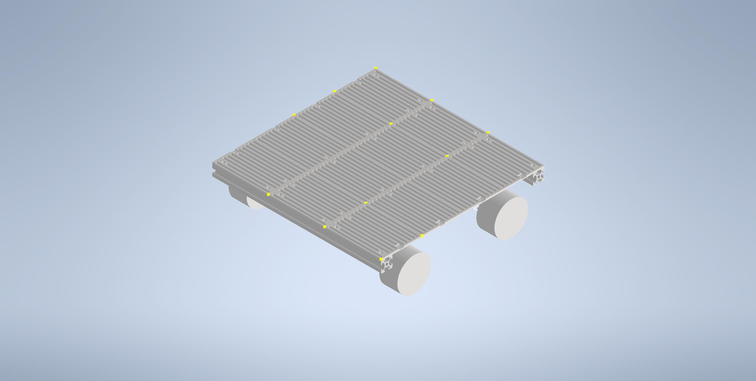

*Figure 1. Overall Layout with Slotted Sheets*

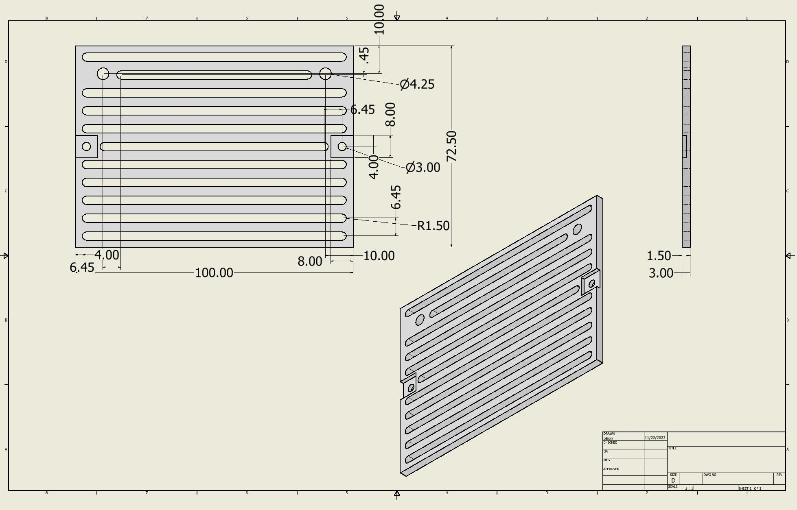

*Figure 2. End Slotted Sheets*

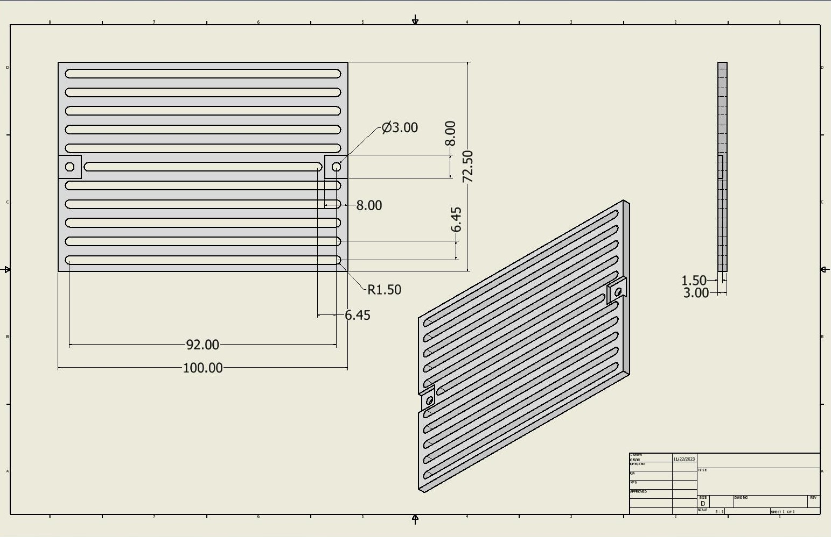

*Figure 3. Middle Slotted Sheets*

**Logic, General Notes, Reasonings**

*Slotted Sheets*

This subsystem was very abstract from conception and changed over time once being created in real life. Originally, the team was going to have different size walled trays that would contain each subsystem so that they could be moved like puzzle pieces around the robot. However, this was not a viable option due to the size of the robot and how much individual components would need to be moved. This is how the slotted sheets were thought of and designed. Components for every competition would need to be placed in different locations and orientations. Therefore, having something that all components could be attached to would be the most ideal solution. The design was inspired by a peg board, but with a twist. The likelihood of components aligning with these holes exactly was slim to none. Therefore, rows of slots were used to that if all holes would not align then two corners could be connected by rotating components slightly to align them. For robot purposes, only having corners anchored would be sufficient enough to attach them. For components without holes for screws could also be zip tied down. The width of the slots was selected to be large enough to accommodate the largest holes on a component. This can be changed in the 3D model for future teams. Next, the slots were split into sections to be able to accommodate future teams by changing the layout dimensions. Similarly to the width of the slots, this can also be changed as needed for future team by editing the 3D model. The suggested additions would be to add additional securing points to the chassis than just the four corners. The connecting pieces designed to work and with all components pushing down on the top keep the sheets stable, but it could be more secure when turned on its side. Also, I would suggest increasing the thickness of the sheets. For this iteration, we had strict height requirements and could not make this change.

*Wire Organization*

Previous competition teams have had many issues stemming from not having a properly organized wire. Having jumbled wires are difficult to trace for issues occurring and rewiring components. Jumbled wires are easier to come unplugged and as a result shorting components becomes a lot easier. Therefore, things like Arduino and sensors would be shorted mid competition. Therefore, implementing some kind of organization to keep wires as short as possible is important. Additionally, grouping wires from the same component and labeling them can further this so anyone can trouble shoot easily. What our robot looked like after organizing and labeling is seen below.

*Stand-off Screws*

Standoff screws were used to aid in raising microcontrollers to allow for stacking of the Arduinos and utilizing space under the Jetson-Nano. Both of these allowed the team to save space on the layout to ensure we could fit into our space restrictions.

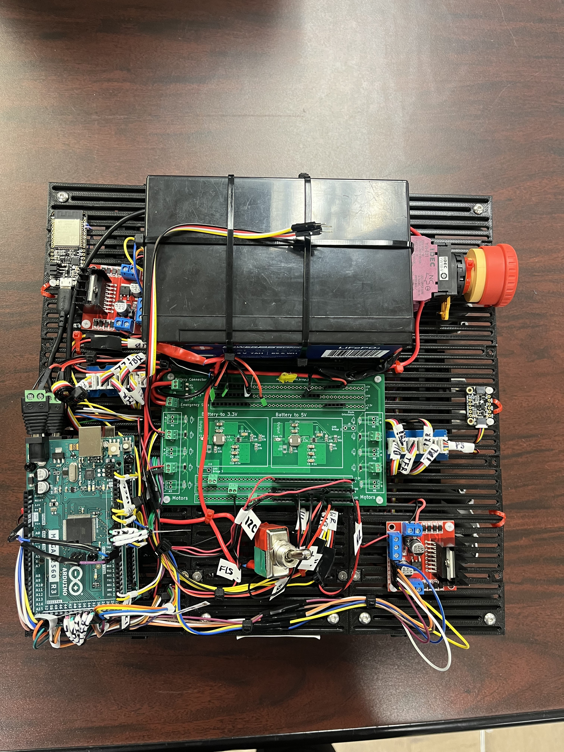

*Figure 4. Wire Organization*